HOW DO THE ACTION AREAS OF THE OTTAWA CHARTER REFLECT SOCIAL JUSTICE PRINCIPLES
The principles of social justice - equity, diversity and supportive environments - are an essential part of effective health promotion. The Ottawa Charter promotes social justice as it is designed to provide access to health opportunities for all members of a community and aims to reduce the level of health inequalities in Australia.
The Ottawa Charter identifies three basic strategies for health promotion. These are advocacy for health to create the essential conditions for health indicated above; enabling all people to achieve their full health potential; and mediating between the different interests in society in the pursuit of health.
These strategies are supported by five priority action areas as outlined in the Ottawa Charter
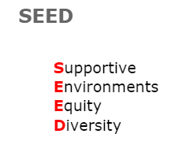
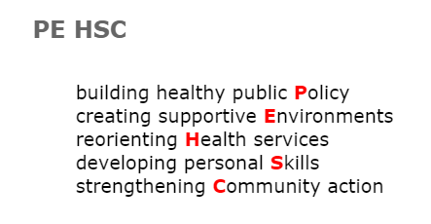
ACRONYMS

Complete the table below to show how the Ottawa Charter addresses social justice
ACTION AREA | EQUITY | DIVERSITY | SUPPORTIVE ENVIRONMENT
Develop personal skills  - Knowledge & Skills  Health promotion supports personal and social development through providing information, education for health, and enhancing life skills. By so doing, it increases the options available to people to exercise more control over their own health and over their environments, and to make choices conducive to health. | Access to knowledge – distance education programs | Resources are provided in multiple languages | The passing down of knowledge from parent to child
Re-orient health services
- Prevention over cure
The responsibility for health promotion in health services is shared among individuals, community groups, health professionals, health service institutions and governments. They must work together towards a health care system which contributes to the pursuit of health.

Strengthen community action
- Empowering communities
Health promotion works through concrete and effective community action in setting priorities, making decisions, planning strategies and implementing them to achieve better health. At the heart of this process is the empowerment of communities - their ownership and control of their own endeavours and destinies.

Create supportive environments
- Enabling healthy environments
Our societies are complex and interrelated. The overall guiding principle for the world, nations, regions and communities alike, is the need to encourage reciprocal maintenance - to take care of each other, our communities and our natural environment.

Build healthy public policy
- Laws and policies
Health promotion goes beyond health care. It puts health on the agenda of policy makers in all sectors and at all levels, directing them to be aware of the health consequences of their decisions and to accept their responsibilities for health.

Social justice means that the rights of all people in our community are considered in a fair and equitable manner. While equal opportunity targets everyone in the community, social justice targets the marginalised and disadvantaged groups of people in our society. In a socially just community public policies should ensure that all people have equal access to health care services, for example the Medicare system in Australia. People living in isolated communities should have the same access to clean water and sanitation as a person living in an urban area. People of a low socioeconomic background should receive the same quality health services that a person in a higher socioeconomic income receives. Information designed to educate the community must be provided in languages that the community can understand.

